1. Contextualization

XYZ Company wants to build an online movie ticket booking platform that caters to both B2B (theatre partners) and B2C(end customers)

1. Key Goals

* Enable theatre partners to onboard their theatres over this platform and get access to a bigger customer base while going digital.
* Enable end customers to browse the platform to get access to movies across different cities, languages, and genres, as well as book tickets in advance with a seamless experience.

1. High Level Architecture

* Will be using 3-tier architecture with distinct layers
* Each layer will have a unique set of responsibilities, viz
  + Presentation
  + Service
  + Persistence
  1. **Theatre Management System**

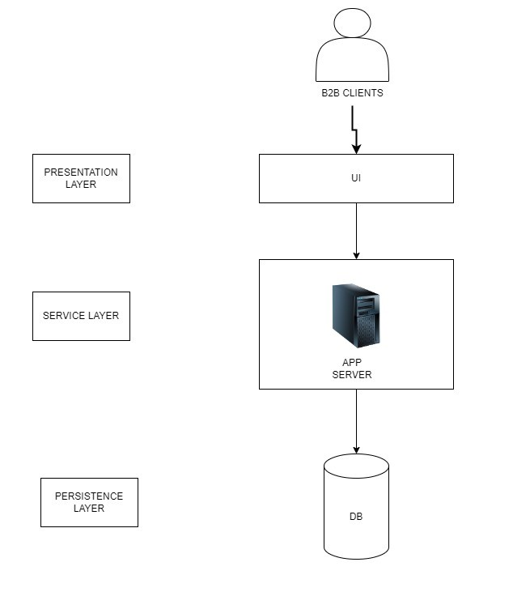

* 1. **Ticket Booking System**

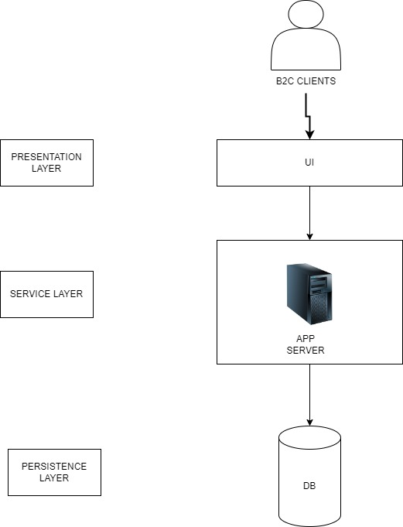

1. Low Level Architecture

